Graph Theory
A graph is a mathematical model which servers as a representation of objects and relations between them. The objects can be anything, and relations are always between pairs of objects.
Formal definition:

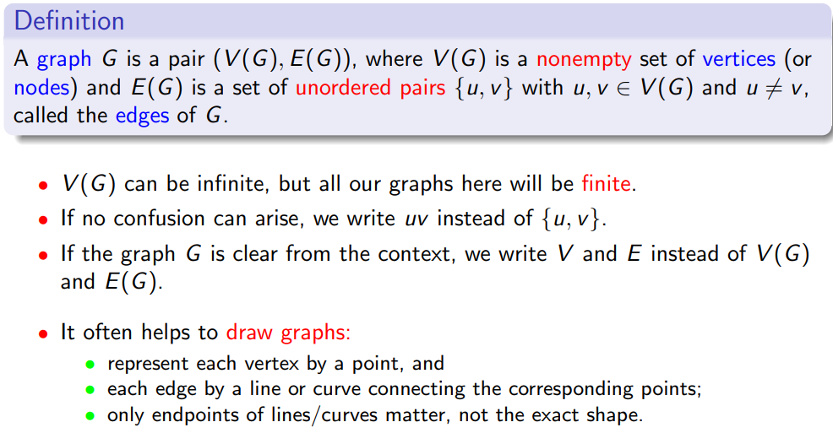
Example:

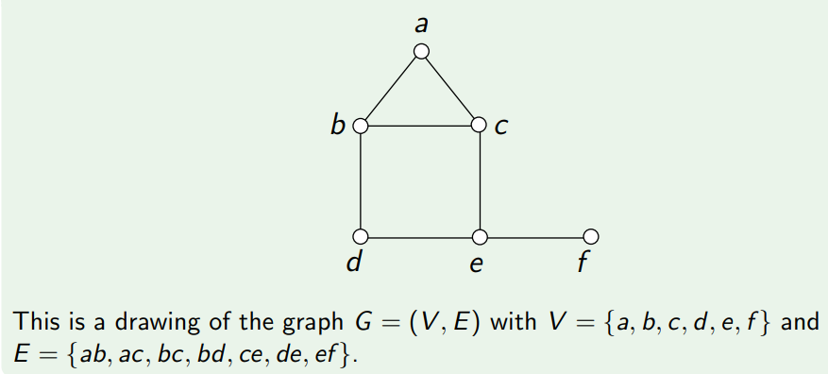

Types of graph:
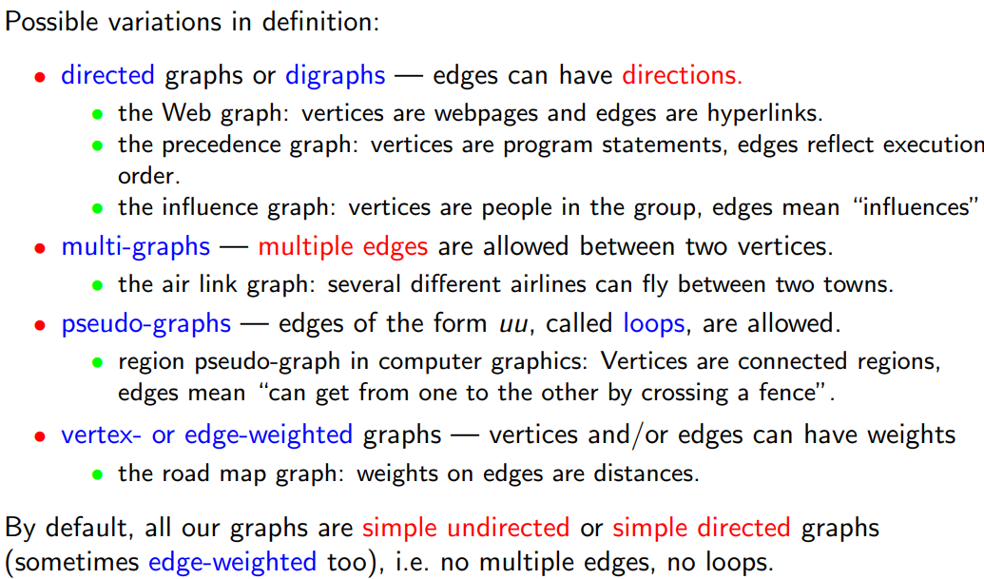
Dominating set – a set of nodes where every node in the graph shares an edge with a node in the set
Minimum dominating set – the smallest possible dominating set
Independent set – a set of nodes who do not share edges with any other nodes in the set.
Maximum independent set – the largest possible independent set.
Minimum colouring – partitioning a graph into the smallest number of independent sets.

A complete graph is one which has every possible edge.

Graphs can be used to express conflicting situations between objects, e.g. vertices are base stations for mobile phones, edges are overlapping service area. They can also be used to analyse strategies and solutions, e.g. vertices are states in a game (e.g. state of a chessboard), edges are transitions between states.
Terminology:
- Let G be a graph, and uv be an edge in G
- u and v are called the endpoints of uv
- u and v are called neighbours, or adjacent vertices
- uv is said to be incident to u, and to v
- If vw is also an edge, w != u, then uv and vw are adjacent.
- The neighbourhood of a vertex v, denoted N(v), is the set of neighbours of v
- The degree of a vertex v, denoted deg(v), is the number of neighbours of v, i.e. deg(v) = |N(v)|
- With δ(G), or δ, we denote the smallest degree in G, with Δ(G), or Δ being the largest degree
- A vertex with degree 0 is an isolated vertex
- A vertex with degree 1 is an end vertex, or a pendant vertex.
- A subgraph G’ of G is a graph with its set of vertices, V’ a subset of the set of vertices of G, V. This subgraph is called proper if G’ does not contain all the vertices of G, and is called spanning if V’ = V. G’ is called an induced subgraph if it contains all the edges that exist in G between all the vertices in V’.
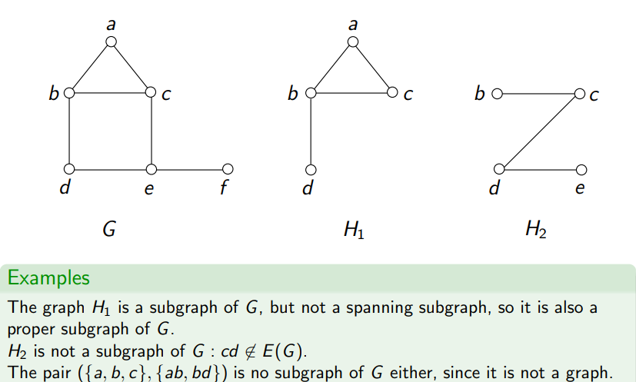
Examples:
^ the last one has an edge bd but no vertex d so cannot exist.

First Theorem of Graph Theory (Handshaking Lemma):
The sum of the degrees of the vertices of a graph G is equal to 2 times the number of edges in G
Proof – every edge has 2 endpoints, and contributes 1 towards the degree of each endpoint, i.e. adds 2 to the total sum of degrees of vertices.
This theorem can be useful in proving non-existence of graphs with certain properties, i.e. if this property is not satisfied it is not a graph.

Corollary:
In every undirected graph G, the number of vertices with an odd degree is even. (i.e. an even number of vertices in G have an odd number of neighbours).
Proof: from Handshaking Lemma, we know the sum of the degrees of vertices equals 2x the number of edges in the graph, i.e. is an even number. Need an even number of odd degree vertices in order to make the sum of degrees even.

Graph classes:
P_{n}:
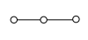
P_{n} is the path on n vertices, i.e. a graph with n vertices and n-1 edges, in a straight line. A path in a graph G is a subgraph which is isomorphic to the graph P_{k} for some integer k >= 1

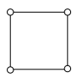
C_{n}:
C_{n} is a cycle on n vertices, i.e. the graph has n vertices and n edges.

K_{p,q}:
A complete bipartite graph consisting of two disjoint vertex sets on p and q vertices, and all possible edges between these two sets ( and no other edges), so it has (p * q) edges. I.e. every edge has one endpoint in each vertex set.

K_{n}:
A complete graph on n vertices, containing all possible edges between pairs of vertices. Has 0.5n(n-1) edges.

Q_{n}:
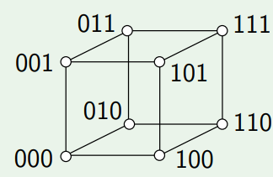
The graph with in which two vertices are neighbours iff the corresponding rows differ in exactly one entry, where all e_{i} are binary digits.

Walks, paths, cycles, distances
A walk in a graph G is a sequence of edges v₀v₁, v₁v₂, …, v_{(n-1)}v_{n}, we can also say v₀, v₁, …, v_{n} is a walk in G
A walk v_{0,} v₁, … , v_{n} in G is a path if all v_{i}s are distinct.
(i.e. walks can go back to already visited vertices, paths cannot)
A walk v₀, …, v_{n} with v₀=v_{n} is a circuit or closed walk.
A closed walk is a cycle, or a simple circuit, if all v_{i}’s in it are distinct, except for v₀=v_{n}
If G is directed, then the directed paths and directed cycles are defined as expected.
The length of a path or cycle is the number of edges in it.
The distance between vertices u and v, denoted dist(u,v), is the length of a shortest path from u to v if such a path exists, otherwise infinity if no such path exists.
The diameter of a graph is the largest distance between 2 vertices in it, i.e. the longest shortest distance .

The collaboration graph is a graph whose vertices are all people (scientists), with edges between 2 of them if they have a joint research paper. The Erdos number of a person is the minimum distance between them and some fella called Paul Erdos in the collaboration graph.
The Bacon Number is the same thing for Hollywood actors and their distance from Kevin Bacon.
The Erdos-Bacon number of a person is the sum of their Erdos number and their Bacon number
(why the fuck is any of this relevant??)

Shortest path problem: In a graph, possibly with edge weights, the problem of computing a path from a given “source” vertex u to a given “target” vertex v with the smallest total length or weight is known as the shortest path problem.
Connectivity: A graph G is called connected if, between every pair of vertices u,v there exists at least one path in G. A connected component of G (if G is not connected) is a maximal connected subgraph of G, i.e. distinct subgraphs of G that are connected. Note- maximal means it ceases being connected if you add any more nodes of G to the subgraph, NOT the largest possible component – a graph can have multiple connected components.
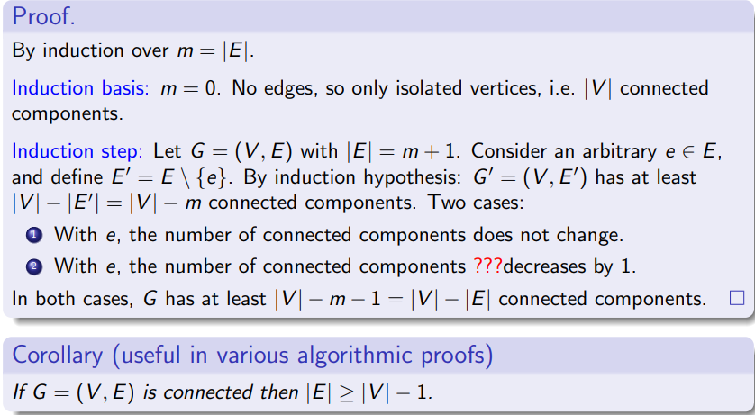
Theorem: Every graph G(V,E) contains at least |V|-|E| connected components.
Note: m often used to denote number of edges, n for number of vertices.
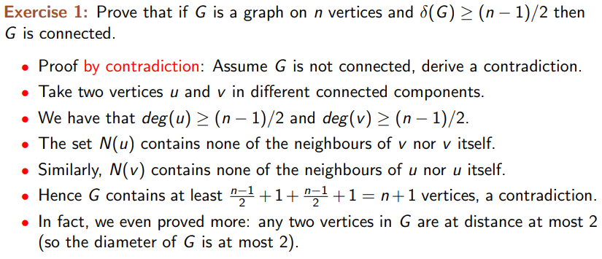
^small delta = minimum degree

Strong connectivity of directed graphs:
- A directed graph G is weakly connected if the undirected graph obtained from G by removing directions is connected
- A directed graph G is strongly connected if any 2 distinct vertices are connected by directed paths in both directions.
- A strongly connected component of a digraph G is a maximal strongly connected subgraph.

Special cycles in graphs:
- An Eulerian circuit/cycle is one where we start and finish at the same vertex, traversing each edge exactly once.
- A Hamiltonian cycle is one where we start and finish at the same vertex and visit each vertex exactly once.
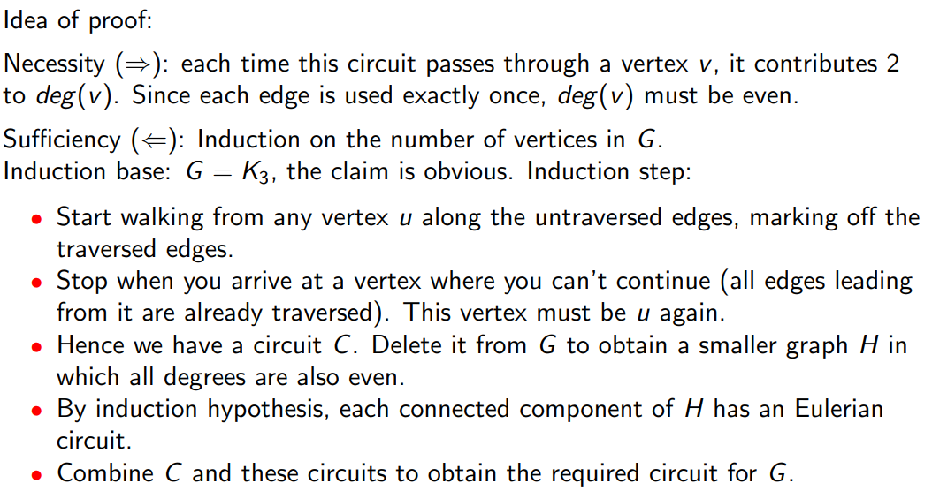
Theorem: A connected graph with at least 2 vertices has an Eulerian circuit iff each of its vertices has even degree.
Detecting Eulerian cycles is algorithmically easy – check the degrees of each vertex.
Detecting Hamiltonian cycles is hard – NP-complete. Can be seen as equivalent to the Travelling Salesman Problem – cities are nodes and edges are possible routes.
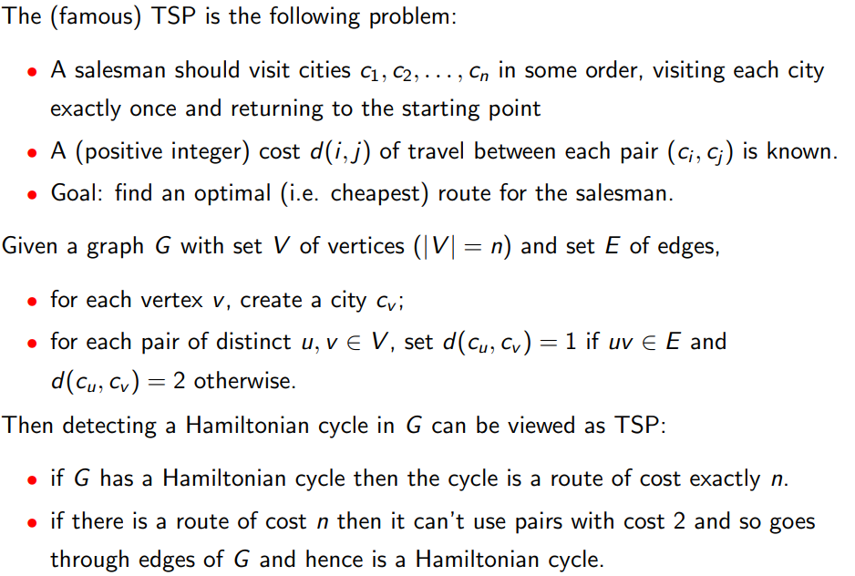

Trees and Forests
Definitions: A forest is an acyclic graph, i.e. a graph without cycles
A tree is a connected forest, i.e. a connected acyclic graph, i.e. a path exists between every pair of vertices.
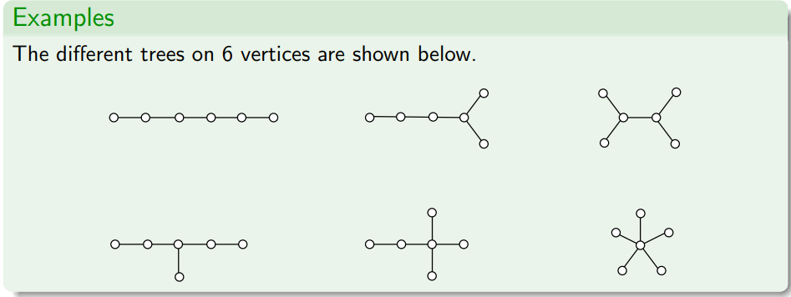
^Treating these 6 trees as a single graph results in a single forest on 36 vertices
Spanning trees:
A subgraph G’ = (V’, E’) of a graph G = (V,E) is spanning if V’ = V, i.e. same nodes but different number of edges.
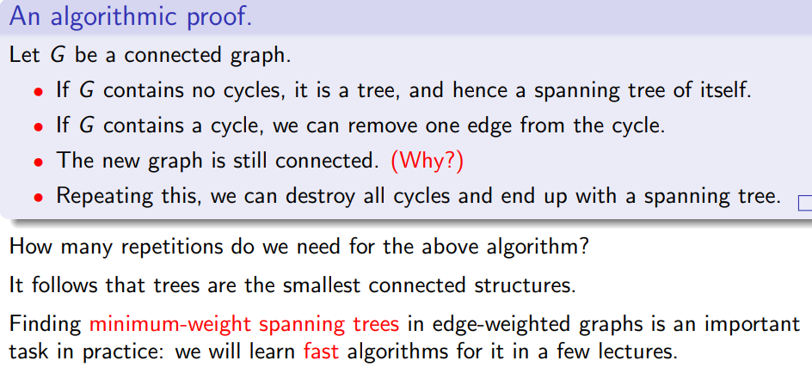
Theorem: Every connected graph contains a spanning tree (a spanning subgraph that is also a tree).

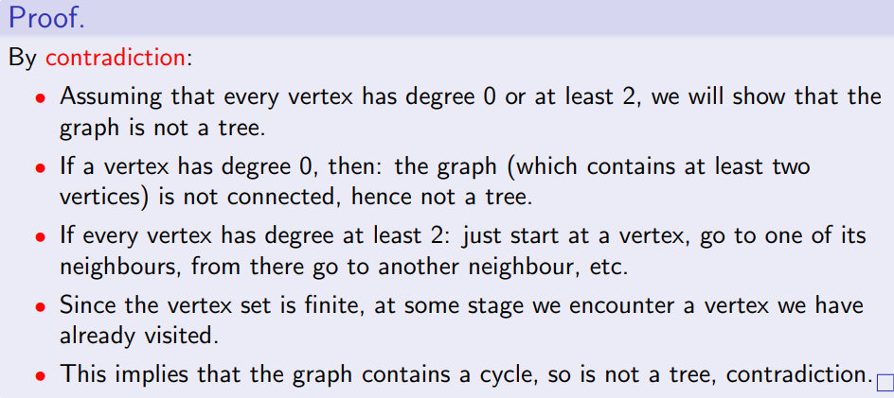
A leaf in a tree is a vertex with degree 1. Every tree on at least two vertices contains a leaf.

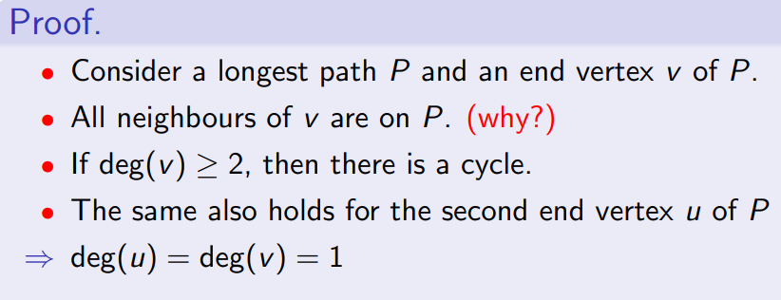
Every tree on at least 2 vertices contains 2 or more leaves.
^ All neighbours of v are on P as if one neighbour w wasn’t on P, then P could be extended from v to w, meaning P is not the longest path. Hence by contradiction, all neighbours of v are on P for P to be the longest path.

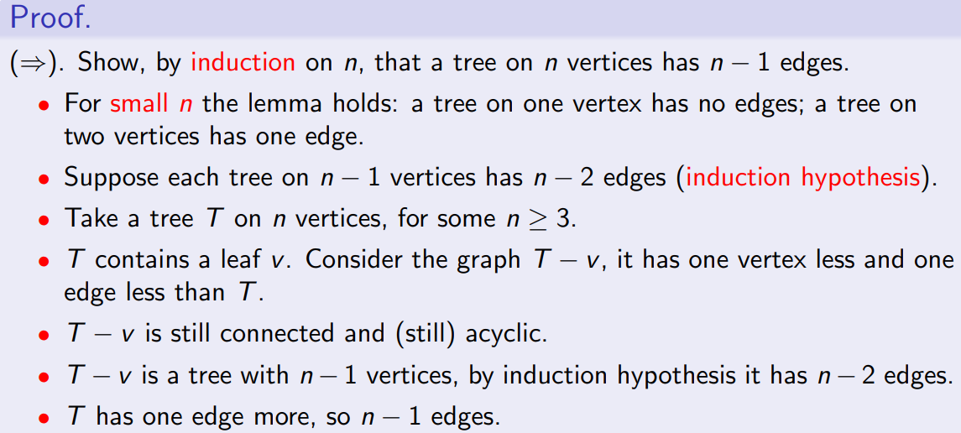
Theorem: A connected graph on n vertices is a tree iff it has n-1 edges.

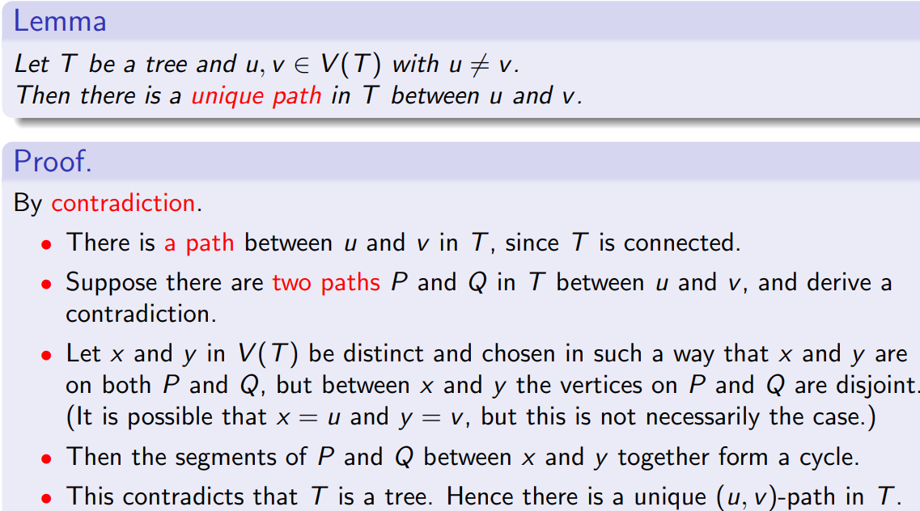
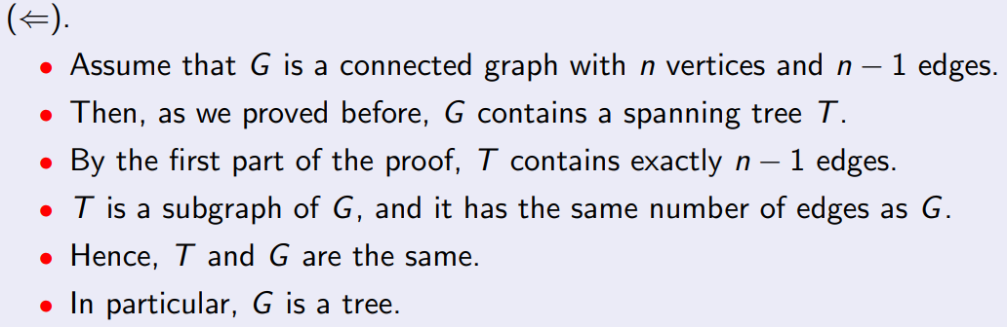
There is only one path between any 2 given vertices in a tree.
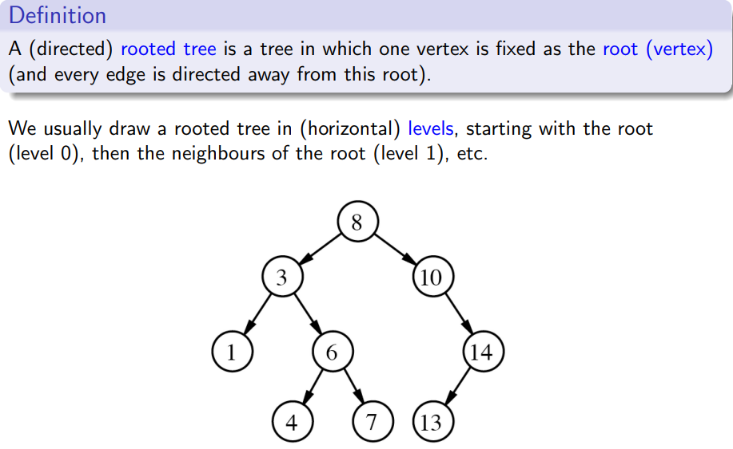
Rooted trees:
Let v be a vertex in a rooted tree T
- The neighbours of v in the next level down are called the children of v
- The single neighbour of v in the previous level is called the parent of v
- If v has no children then it is a leaf of T
- If v has children then it is an internal vertex
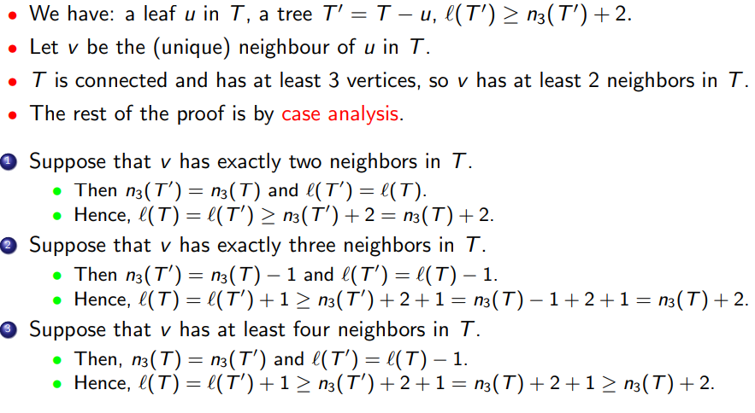
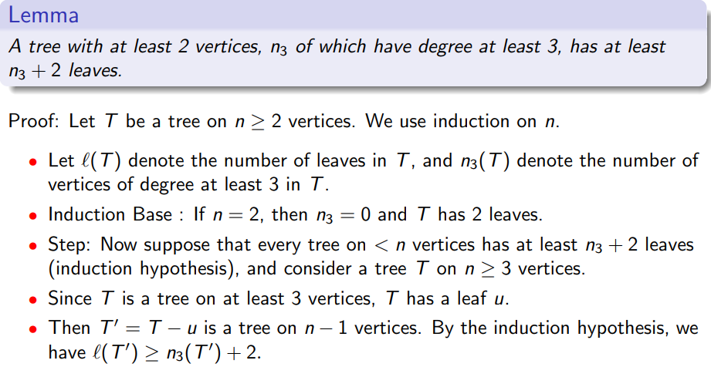
Minimum number of leaves in a tree:
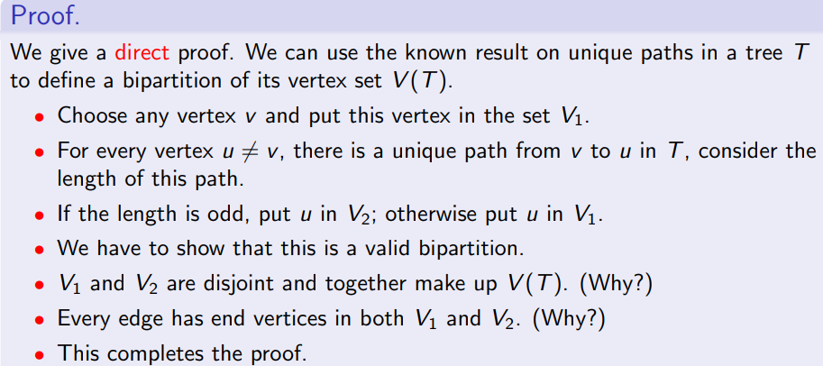
Every tree is a bipartite graph:

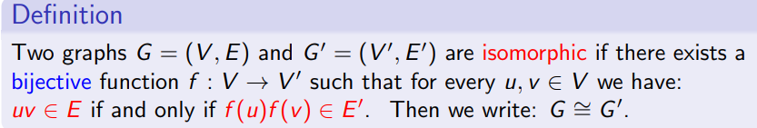
Graph isomorphism:

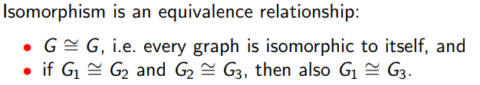
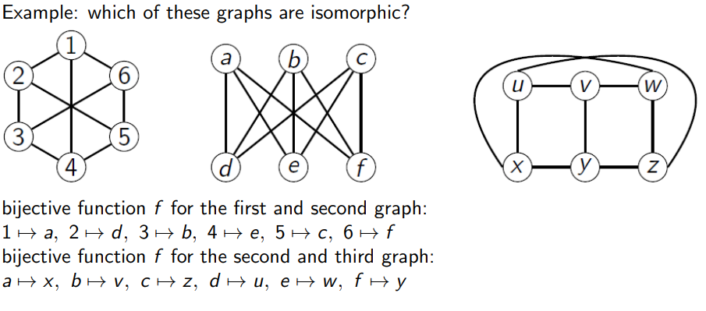
In other words, there exists a corresponding between the vertices of G and G’ which maintains the neighbourhood property, i.e. there exists a renaming of the vertices of G such that it coincides with G’
Quickly deciding whether or not two graphs are isomorphic is neither an easy problem nor an NP-complete problem, but somewhere in between.
If G and G’ are isomorphic then they share all their natural characteristics, e.g. number of vertices, degree sequence, connectivity, Euler and Hamiltonian cycles, size of largest independent set etc, but these are not enough to prove 2 graphs are isomorphic – can only use these to prove non-isomorphism.
Isomorphism of rooted trees:
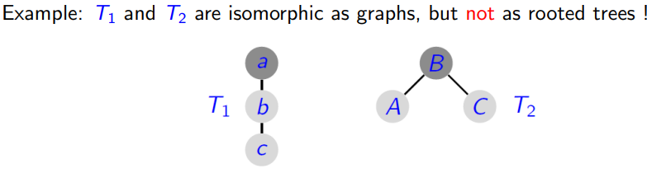
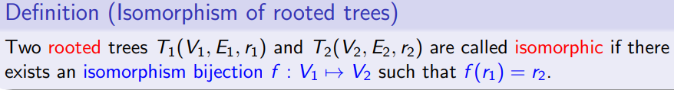
i.e, the graphs represented by the trees have to be isomorphic AND the root has to be conserved by the function that “renames” the nodes.

Level of a rooted tree:
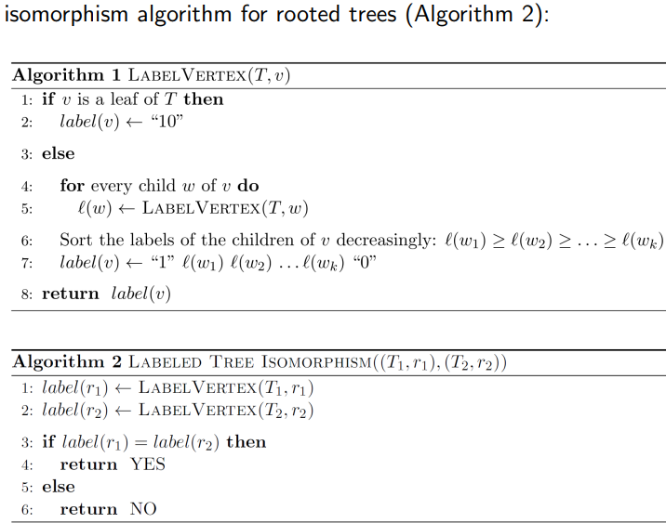
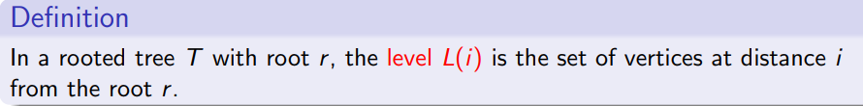
^i.e. L(i) represents the set of vertices at h=the ith level
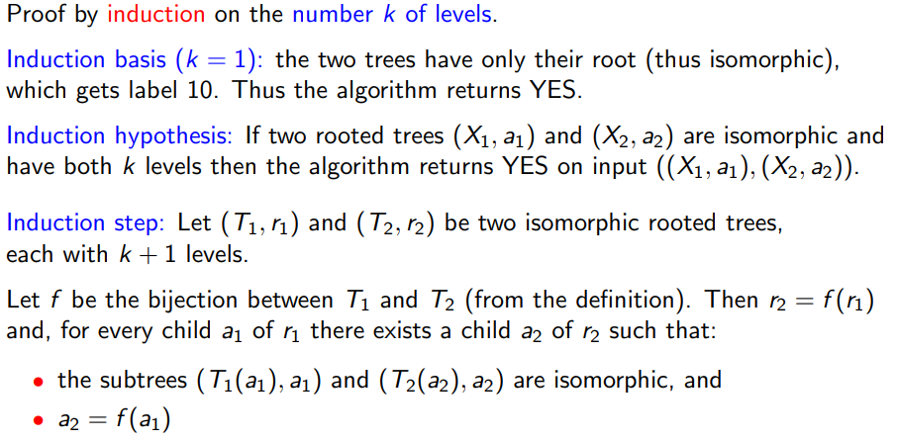
Theorem: If (T₁, r₁) is isomorphic to (T₂, r₂) then Algorithm 2 above returns YES
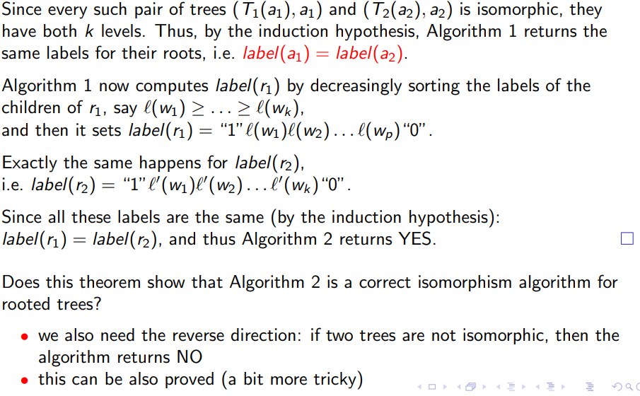
(note: labelling is determined by algorithm 1)

Representations of graphs:
A graph G(V,E) has a pair of sets: V and E
To give an adjacency list representation of a graph, for each vertex v list all the vertices adjacent to v, e.g. each vertex points to the next in the list
To give an adjacency matrix representation, create a square matrix A and label the rows and columns with the vertices: The entry in row i and column j is 1 if vertex i is adjacent to vertex i, and 0 if not.
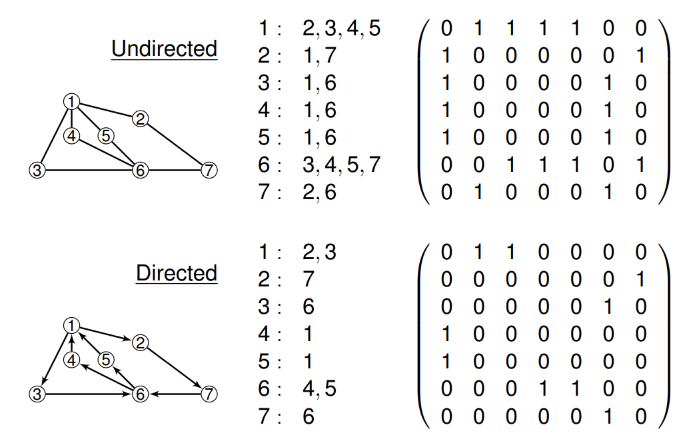
Can also represent a graph using the array of its edges.

Graph G, n nodes, m edges | Space | Time to initialise empty graph | Time to make a copy of graph | Time for inserting edge | Time for listing neighbours of a vertex | Time to find out whether an edge belongs to G
Adj Matrix | N² | N² | N² | 1 | N | 1
Adj List | M+N | n | m | 1 | n | O(n)

Graph Traversals
Breadth First Search (BFS) :
Input: Graph G = (V,E), source vertex s
Aim: To find the distance from s to each of the other vertices in the graph
BFS maintains a queue that contains vertices that have been discovered but are waiting to be processed.
BFS colours the vertices: White = undiscovered, Grey = discovered and unprocessed, Black = processed.
The algorithm maintains an array d (distance):
- d[s] = 0 where s is the source vertex
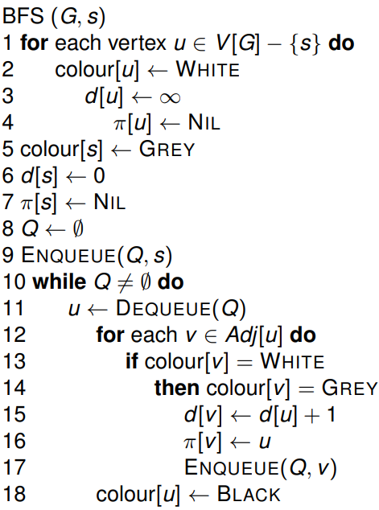
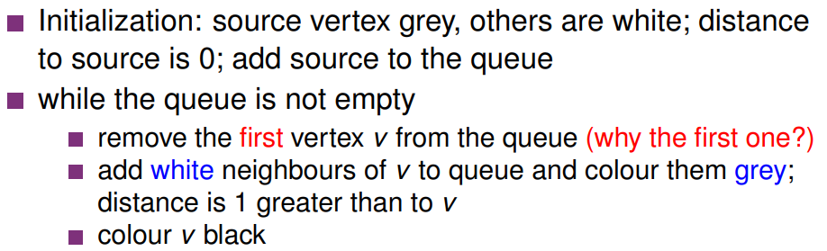
- If we discover a new vertex v whie processing u, we get d[v] = d[u] + 1

Running time analysis:
- Want an upper bound of worst case running time
- Assume updating colour, changing distance, enqueue, dequeue each take constant time
- Initialisation is O(V)
- Each vertex enters and leaves the queue once, so queuing operations in total take O(V)
- In the loop, adjacency lists of each vertex are scanned. Each list read once and combined length of the list is O(E)
- Total running time: O(V+E)
To find shortest path:

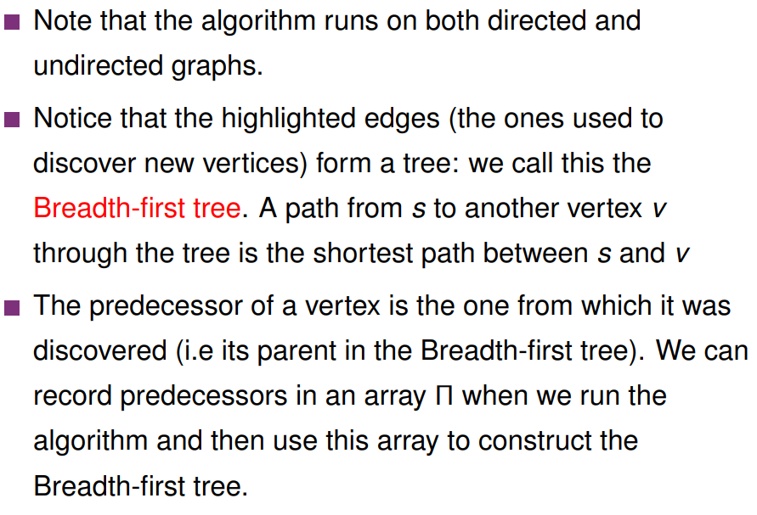
Depth First Search (DFS):
Like BFS, DFS also explores the graph, but does not find distances to the source. When a vertex is discovered it is immediately explored. Two timestamps are recorded for each vertex: discovery time t, and finish time f. We can also record predecessors.
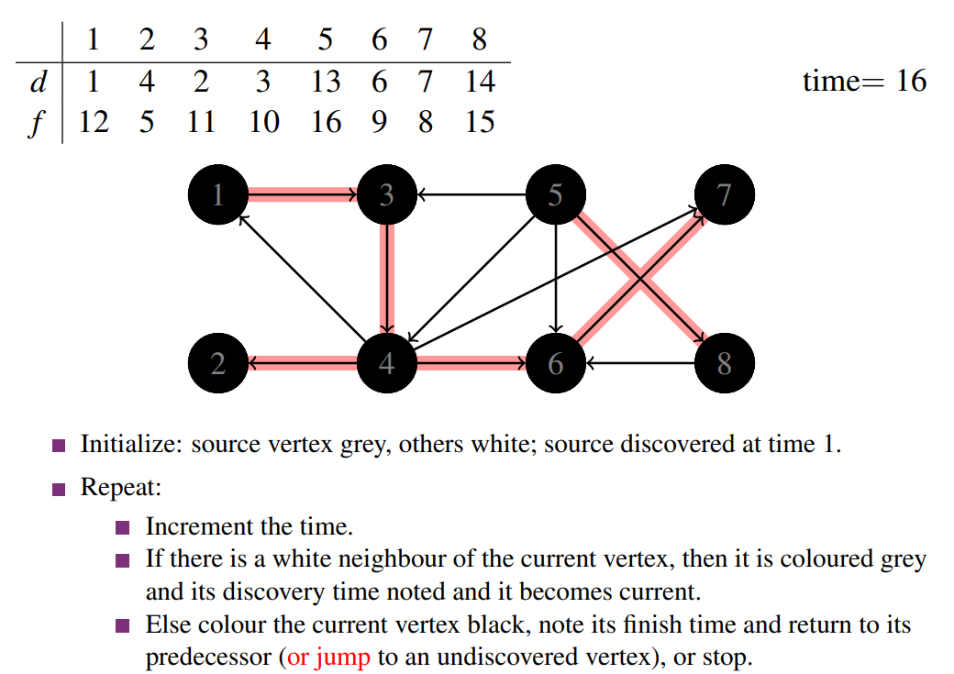
Colours: white for undiscovered, grey for discovered but not finished and black for finished.
There is no fixed rule which white neighbour to go to, as long as it is a white neighbour (racism). If no white neighbours, colour current node black and backtrack. May have to jump to nodes that are not neighbours of any other nodes, e.g. 5 in the above image.
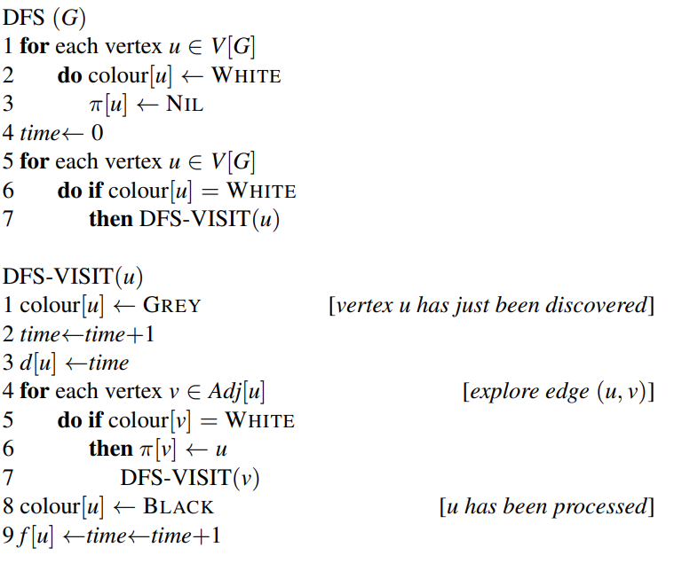
^ pi is the predecessor array showing the parent of each node.

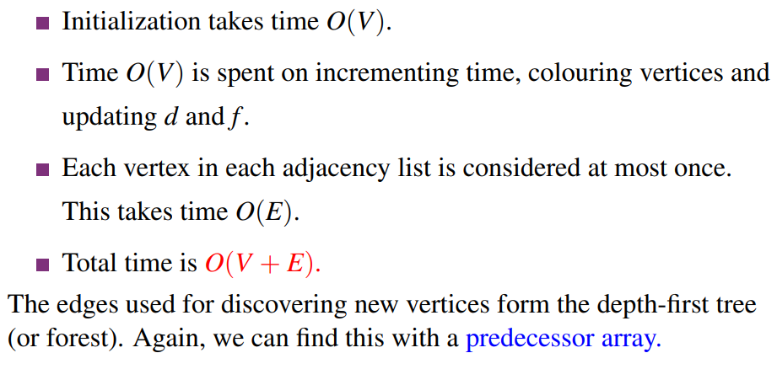
Analysis:
Once we have run DFS on a graph, we can construct the predecessor subgraph, with the same vertex set as the graph, and for each vertex v there is an edge from the predecessor of v to v itself. The predecessor subgraph is a depth-first forest.
From this DFS-forest for a graph G, we can classify the edges of G:
- Tree edges are the edges that are in the DFS forest
- Back edges are edges that join a vertex to an ancestor.
- Forward edges are those not in the tree that join a vertrex to its descendent
- Cross edges are any other edges.
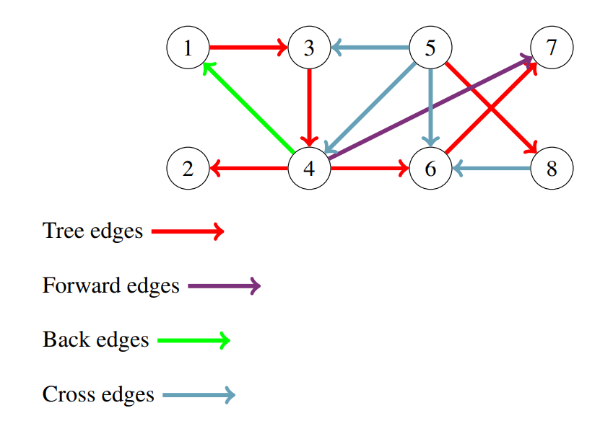
E.g:
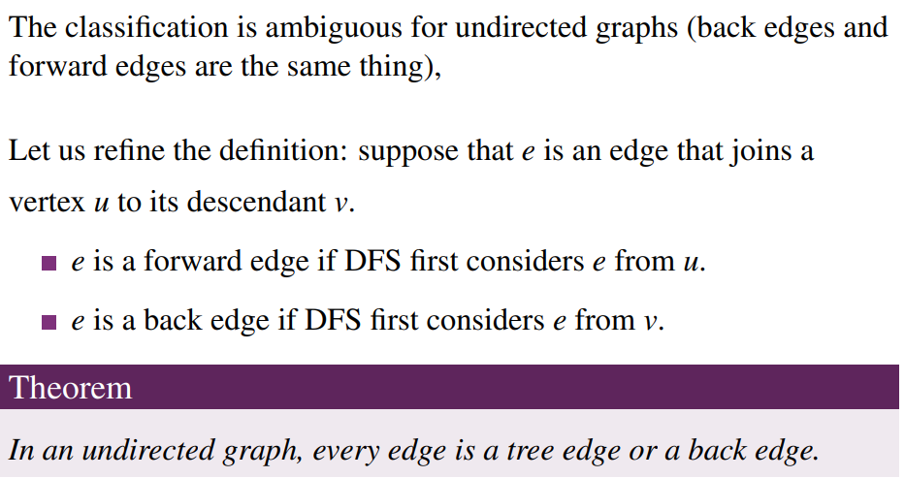
Definition: An articulation point in a graph is a vertex whose removal disconnects the graph.

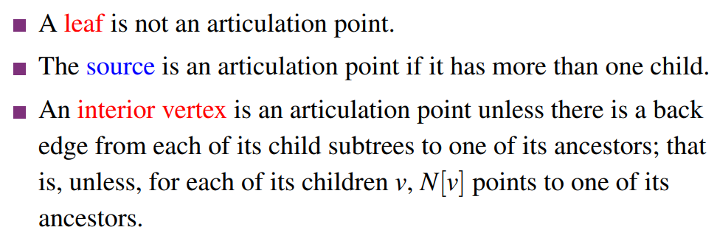
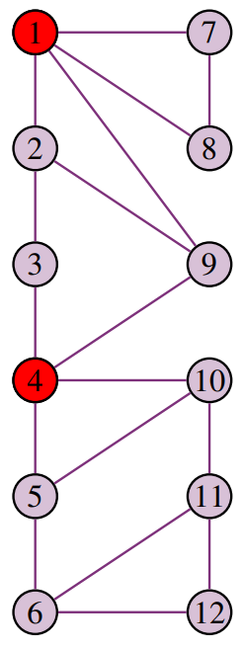
Example:
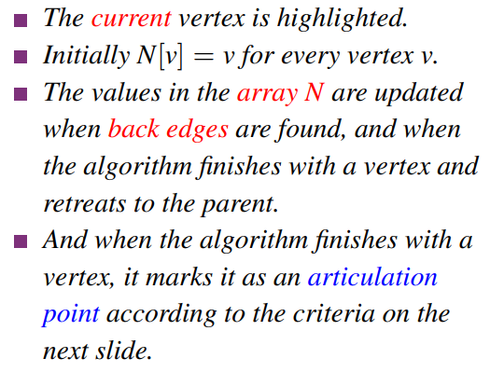
Algorithm for finding articulation points:
<- The criteria are listed above.

Minimum Spanning Trees
Kruskal’s Algorithm – greedy. Obtains a minimum spanning tree by repeatedly adding the next cheapest edge which does not produce a cycle
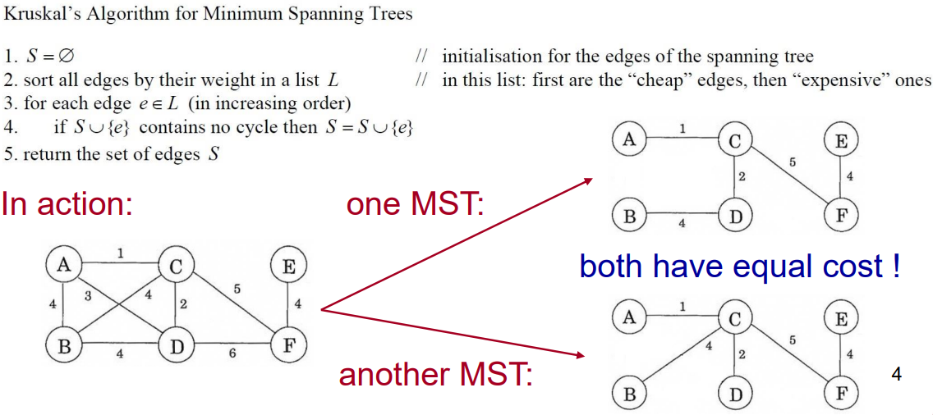
If there is one MST, Kruskal’s algorithm finds it. If there are multiple, it finds one.

Prim’s Algorithm – also greedy. Start with the cheapest edge and repeatedly add to the current connected component the next cheapest edge that does not produce a cycle, until no more such edges exist. This is different to Kruskal’s as it always maintains a connected subgraph.
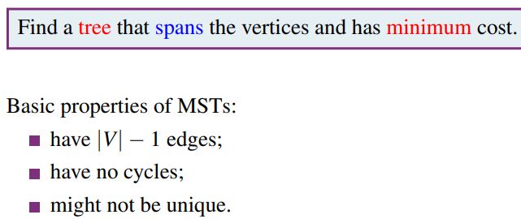
MST Problem:

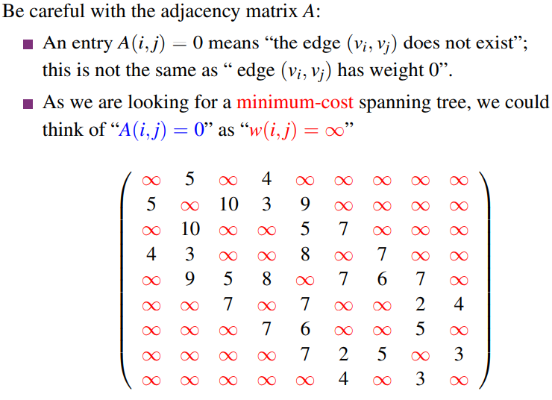
Representing Weighted Graphs:
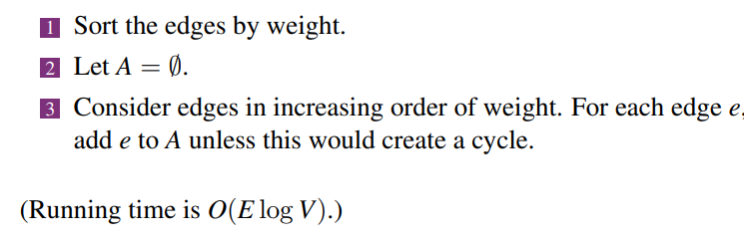
Kruskal’s Algorithm:

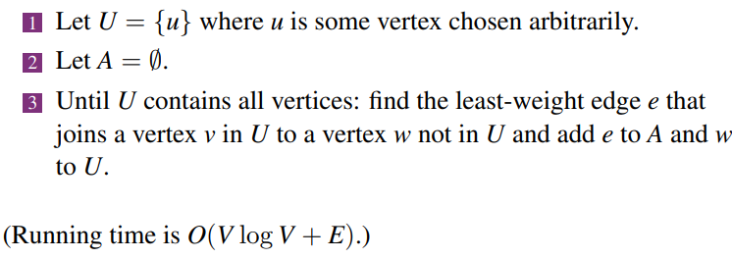
Prim’s Algorithm:

Both Kruskal’s and Prim’s are special cases of a generic greedy MST algorithm:
- We iteratively build a vertex set A such that A is a subset of some MST
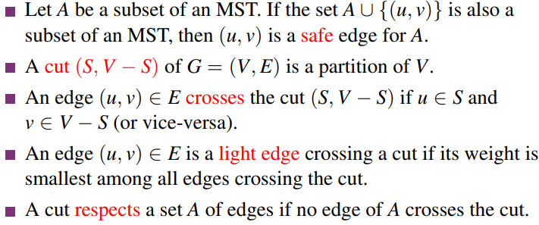
Definitions:
^ A partition is a collection of disjoint subsets, the union of which results in the original set. I.e. the union of S and V-S equals V

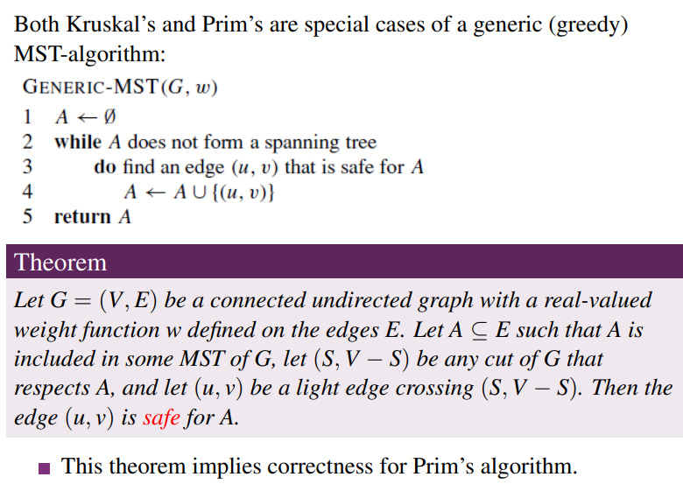
Generic MST Algorithm:
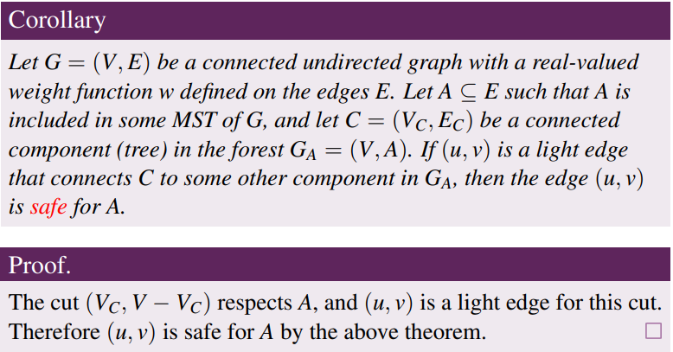
^This corollary implies correctness of Kruskal’s algorithm.

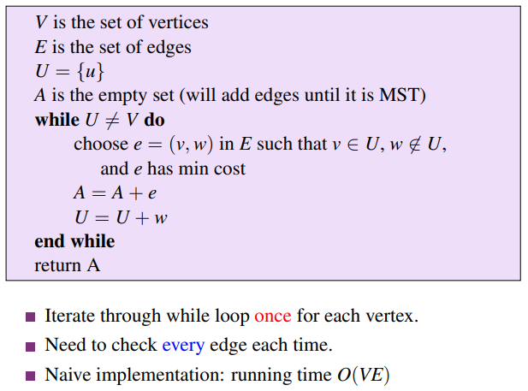
Prim’s Algorithm Implementation:
However, we want to avoid having to check all edges. For each vertex not in U we only want to know the least-weight edge from v to a vertex in U. So we maintain an array to record these values — then we just have to check this array to find which edge to pick next (and then maybe perform some updates).
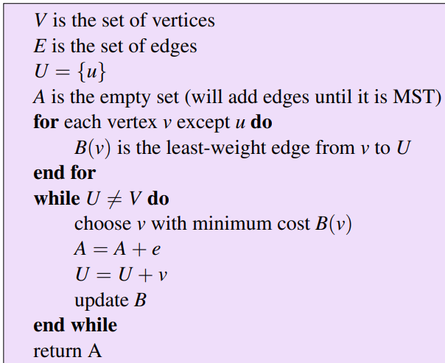
Improved implementation:
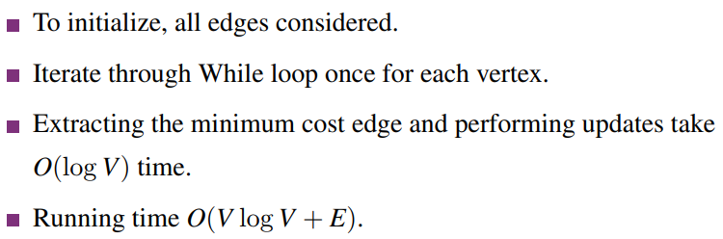
The array can be implemented using a minheap.
Example w/ heap in recording

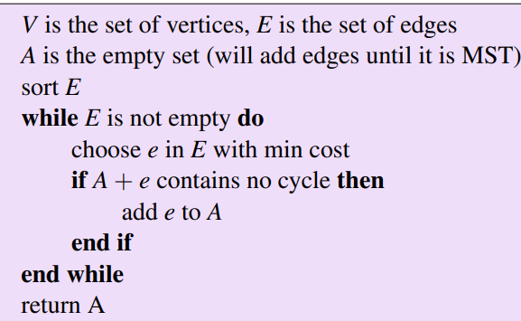
Kruskal’s algorithm implementation:
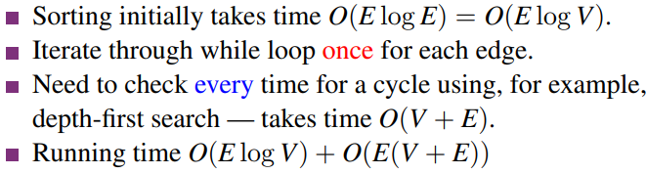
This is a dumb implementation. We don’t want to have to check for cycles all the time. For each vertex v, if we could check which component of the partially built tree it belongs to, we could decide quickly whether or not 2 vertices can be joined without creating a cycle. We can maintain an array to record this.
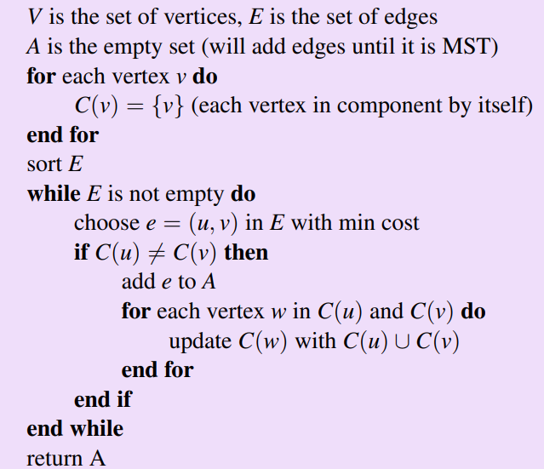
Improved implementation:
^we sort E to always process the smallest length edge.
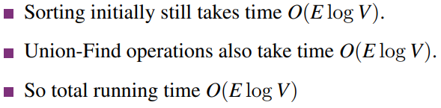
This array can be implemented using the Union-Find data structure.

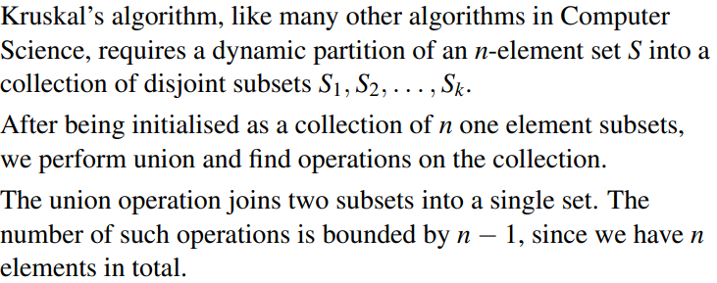
The Union-Find data structure:
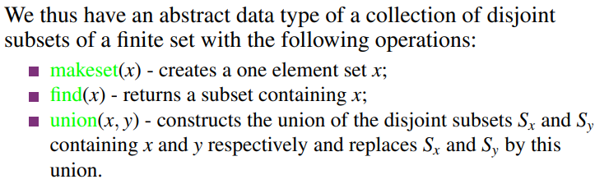
Operations:
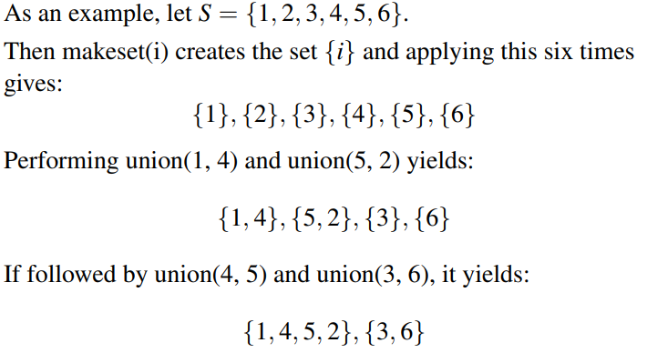
Example:
^we are actually pointing to {1,4,5,2} at elements 1, 2, 4 and 5 of the original array.
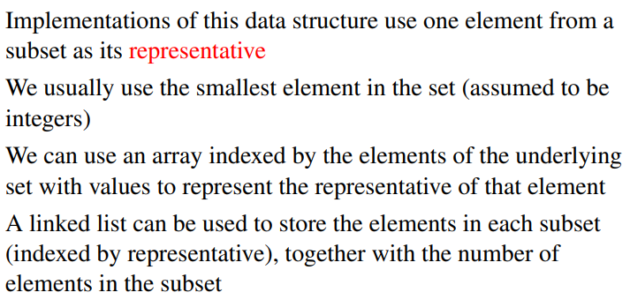
Representation:
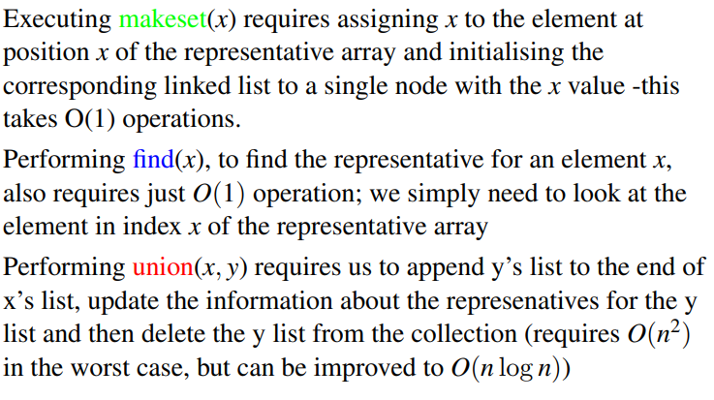
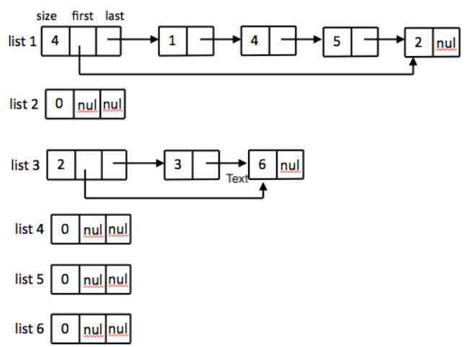
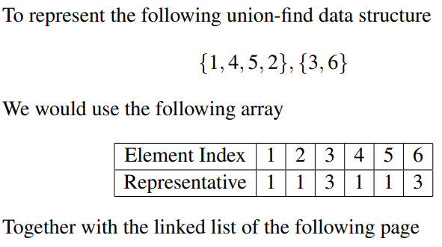
Running time of operations:
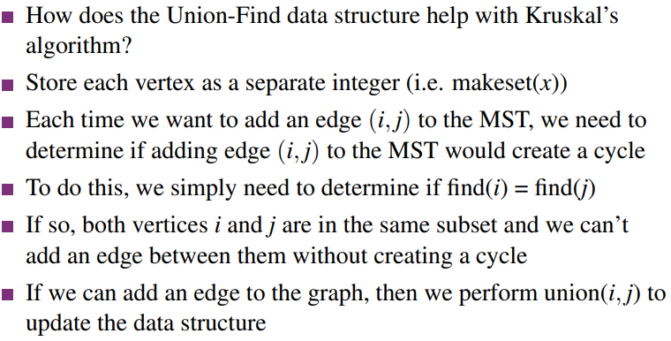
Applying to Kruskal’s algorthm:

